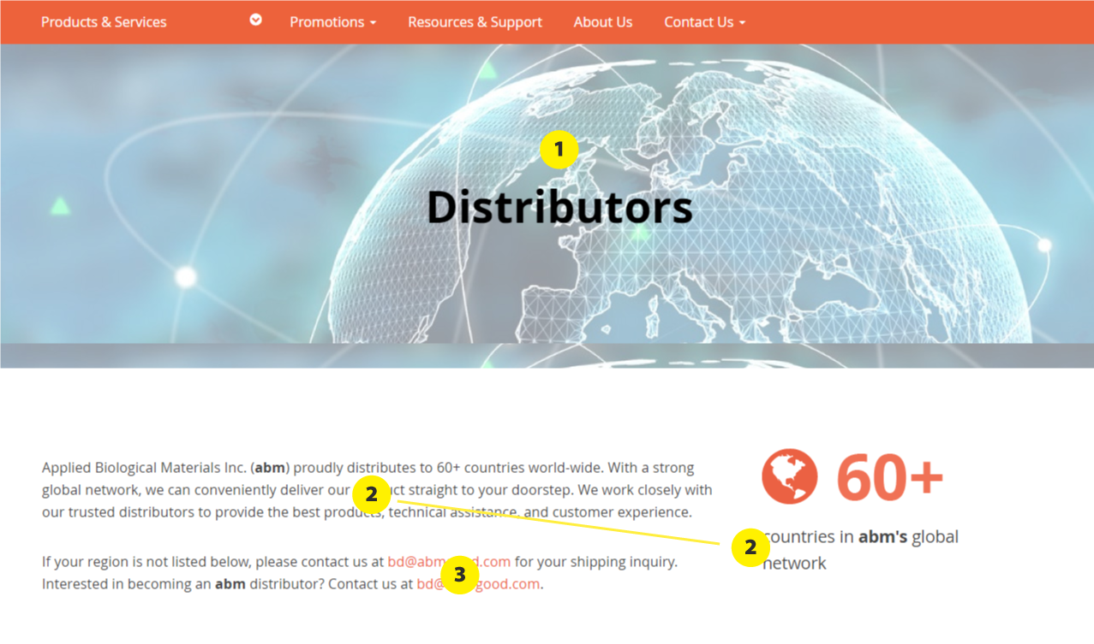

* **1: Banner**
  + We have banners like this on several pages on the website (eg. Resources & Support). You mentioned previously that you’d like to work on them later. Is now a good time?
  + On different pages, the banner image height is different. Can we establish a uniform look for all of them?
    - Image height on desktop should be: 350px
      * Previously, I’ve sent the updated banner images for the different pages and I’ve labelled images with this correct height with “banner-fullbleed-350.jpg” in the file name.
      * Eg. the current banner image on the distributors page is the correct file size (“distributors_banner-fullbleed-350.jpg")
    - background-size: cover;
* **2: Text** 
  + color: #000000;
* **3: Link**
  + On hover:
    - color: #ff734d

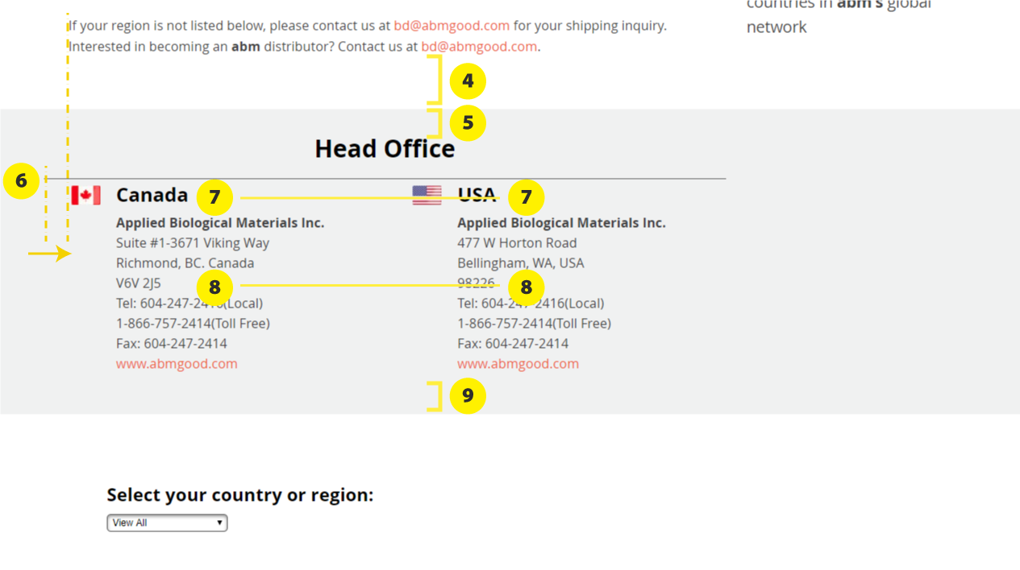

* **4: Spacing**
  + Grey section margin-top: 40px 🡪 50px

* **5: “Head Office”**
  + There should be 80px of space between where the grey section begins and the heading “Head Office”, eg. same as on the [Technical Support & Resources page](https://magento.abmgood.com/support/index/Technical/%20title=):

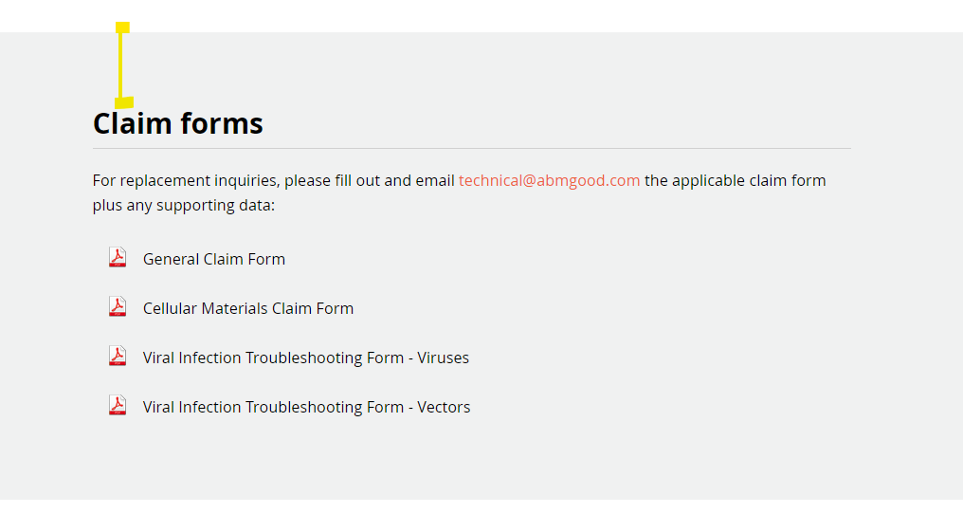

* + Font size for the heading “Head Office” should also match the size of “Claim forms” from the example above (30px)
  + color: #000000;
  + Space between “Head Office” and the horizontal line underneath
    - margin-bottom: 20px 🡪 10px

* **6: Horizontal line**
  + Align the left of the horizontal line with where the text begins in the paragraph above (indicated by the vertical dotted lines in the diagram)
  + Line/border color: #babcbe
  + Space after the line: 20px
* **7: “Canada” and “USA”**
  + color: #000000;
  + font-size: 22px;
* **8: Address and contact information**
  + color: #000000;
  + “Tel: 604-247-2416(Local)  
    1-866-757-2414(Toll Free)”
    - Update to:   
      Tel: 604-247-2416  
      Toll Free: 1-866-757-2414
  + “www.abmgood.com” orange link on hover:
    - color: #ff734d
* **9: Spacing**
  + 50px of space 🡪 80px